**Exercise 7 – Form with Real Time Updating (PHP)**

**Name:** Badri MSV **Roll No:** 195002017

**Subject:** UIT1611 – Web Programming Lab **Faculty:** Dr. S. Sasirekha

**Date:**

**Aim:**

To write an angular program to create form with real time updating.

**Algorithm:**

* Import angular script
* Create the form using the <form> tag and add labels and inputs to the same.
* Set appropriate input types for all parameters.
* Write an angular function to set patterns or Regular expressions as constraints for each input as required.
* Install PHP and MySQL database.
* Create the required database on MySQL with the appropriate database name, username, password, and table.
* Connect the form to the PHP file using the form action tag (refer the last page for code).
* Validate the form by calling the angular function after submitting the form using the ng-controller tag.
* Create a display file, to show all the inputs received into the database, in a table like manner.
* Send alerts if there is an error and after successful submission.
* Display the real-time entries received in the table.

**Code:**

**index.html**

<!doctype html>

<html lang="en">

    <head>

        <title>Card Validation</title>

        <script src="https://ajax.googleapis.com/ajax/libs/angularjs/1.8.2/angular.min.js"></script>

        <script src="https://ajax.googleapis.com/ajax/libs/angularjs/1.8.2/angular-route.min.js"></script>

        <script src="./act.js"></script>

    </head>

    <body ng-app='cc' style="background-color: #EFEBE0;font-family: Arial, Helvetica, sans-serif">

        <main ng-view>

        </main>

        <a ng-href="#!/see">See</a>

    </body>

</html>

**insert.html**

<head>

    <script src="https://ajax.googleapis.com/ajax/libs/angularjs/1.8.2/angular.min.js"></script>

    <script src="https://ajax.googleapis.com/ajax/libs/angularjs/1.8.2/angular-route.js"></script>

    <script src='./act.js'></script>

</head>

<body>

    <h1 align="center" style="background-color:black;color:white;">Payment Details</h1>

    <form style="background-color:grey; height: 400px; width: 900px; padding: 20px;" method="post" action="insert.php">

        <p>Please Enter your details: </p>

        <label for="uname">Name</label>

        <input type="text" id="uname" name="uname" placeholder="abc">

        <br>

        <br>

        <label for="cno">Card Number</label>

        <input type="number" id="cno" name="cno" placeholder="5231" style="width: 50px">

        <input type="number" id="cno2" name="cno2" placeholder="1522" style="width: 50px">

        <input type="number" id="cno3" name="cno3" placeholder="1452" style="width: 50px">

        <input type="number" id="cno4" name="cno4" placeholder="1987" style="width: 50px">

        <br>

        <br>

        <label for="uname">Expiry Date</label>

        <input type="month" id="edate" name="edate" placeholder="2000-12">

        <br>

        <br>

        <label for="cvvcvc">CVV/CVC</label>

        <input type="number" id="cvvcvc" name="cvvcvc" placeholder="456" maxlength="3">

        <br>

        <br>

        <img height="62" width="182" ng-src="Images/card.jpeg">

        <br>

        <br>

        <input type="submit">

    </form>

    <br>

    <br>

</body>

**see.html**

<head>

    <script src="https://ajax.googleapis.com/ajax/libs/angularjs/1.8.2/angular.min.js"></script>

    <script src="https://ajax.googleapis.com/ajax/libs/angularjs/1.8.2/angular-route.min.js"></script>

    <style>

        table{

    width:100%;

    border-collapse:collapse;

    text-align:center;

    border:1px solid #00F;

    font-size:12px;

    }

    </style>

</head>

<body>

    <table>

        <tr>

            <th> Name </th>

            <th> CCNO </th>

            <th> Expiry_Date </th>

            <th> CVV </th>

        </tr>

        <tr ng-repeat="x in tableData">

            <td> {{x.Name}} </td>

            <td> {{x.CCNO}} </td>

            <td> {{x.Expiry_Date}} </td>

            <td> {{x.CVV}} </td>

        </tr>

    </table>

    <a ng-href="#!/insert">Insert</a>

</body>

**act.js**

var app=angular.module('cc',['ngRoute']);

app.config(['$routeProvider',function($routeProvider){

    $routeProvider

    .when('/insert' , {

        templateUrl:'./insert.html',

        controller: "inserter"

    })

    .when("/see",{

        templateUrl:'./see.html',

        controller: "seer"

    })

    .otherwise({

        redirectTo: "/insert"

    })

}]);

app.controller("seer",function($scope,$http){

    $http.get("./see.php")

        .then(function(response) {

            $scope.tableData = response.data;

        });

    $scope.other_part='Insert records';

});

app.controller("inserter",function($scope){

    $scope.other_part='See data';

});

**insert.php**

<?php

    $name=$_POST['uname'];

    $ccno=$_POST["cno"].$_POST["cno2"].$_POST["cno3"].$_POST["cno4"];

    $ed=$_POST['edate'];

    $cvvcvc=$_POST['cvvcvc'];

    $conn=mysqli_connect('localhost','root','','trial');

    $sql = "INSERT INTO `cc_details`(`Name`, `CCNO`, `Expiry_Date`, `CVV`) VALUES ('$name','$ccno','$ed','$cvvcvc')";

    $rs=mysqli_query($conn,$sql) or trigger_error("Query Failed! SQL: $sql - Error: ".mysqli_error($conn), E_USER_ERROR);

    if($rs)

    {

        echo "Data Inserted\n";

    }

    echo "<a href='index.html'>Insert more data</a>";

    mysqli_close($conn);

 ?>

**see.php**

<?php

    $conn=mysqli_connect('localhost','root','','trial');

    $a=[];

    $sql="SELECT * FROM `cc_details`;";

    $result=mysqli_query($conn,$sql);

    while($row=mysqli_fetch_assoc($result))

    {

        array_push($a,$row);

    }

    echo json_encode($a);

    mysqli_close($conn);

?>

**Output:**

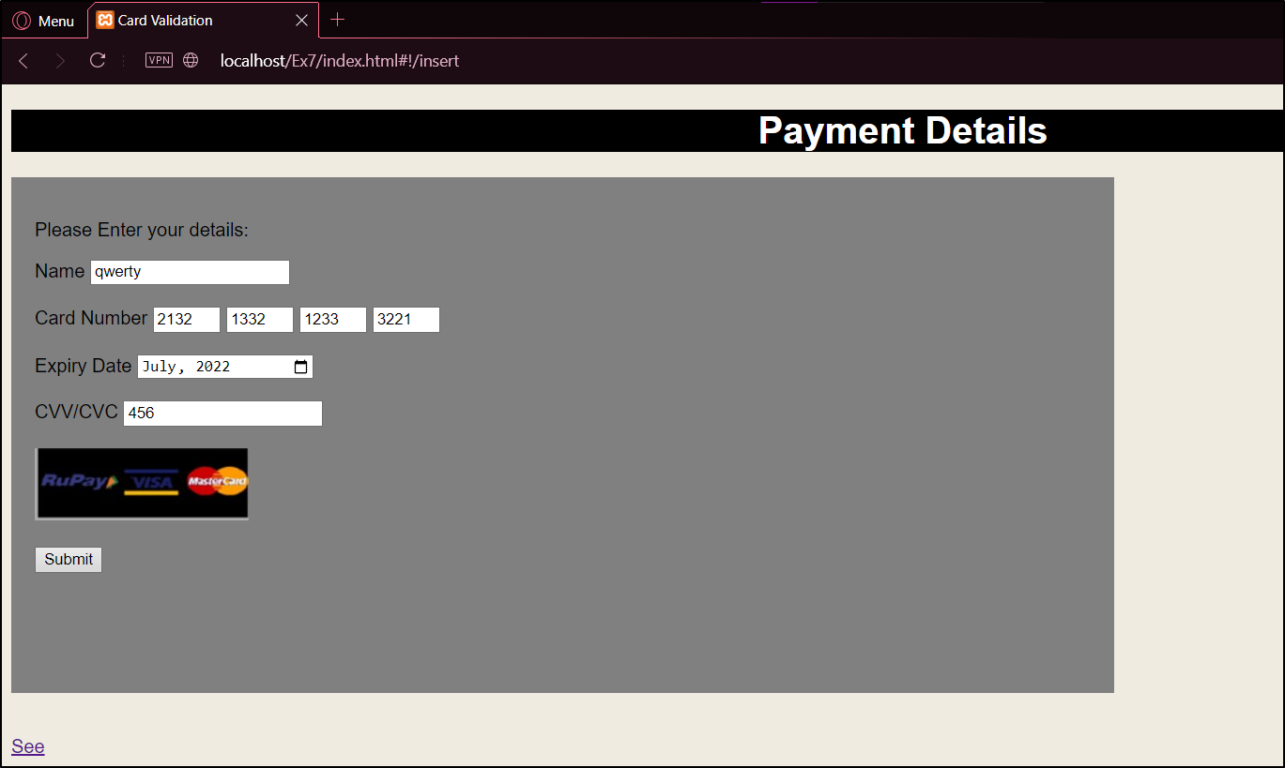

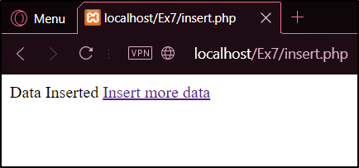

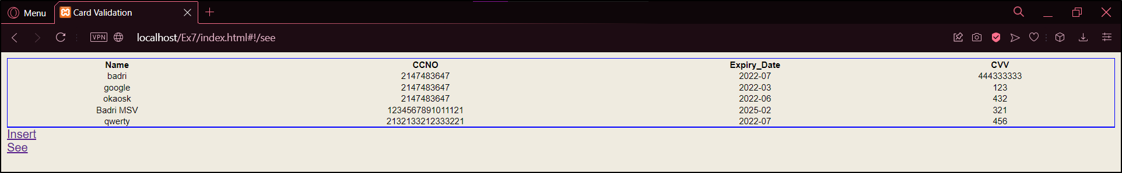

**Result:**

The program to build a form with Real Time Updating PHP and Angular JS is implemented successfully.